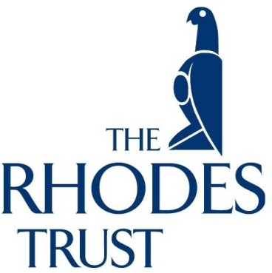

8 June 2018

Dear Student
Congratulations on the outstanding academic results you have achieved in your course.

Your grades place you in the top group of students at Monash University and consequently, if further study at an overseas institution is of interest to you, we suggest that you consider applying for a Rhodes Scholarship to further your academic development at Oxford University in the UK.

The Rhodes Scholarship is one of the oldest and most distinguished scholarships in the world. Previous winners have gone on to careers in politics, medicine, law, education, scientific research and many other fields. We encourage students with a very strong academic record, combined with leadership experience and a demonstrated willingness to work for the good of others, to consider applying.

Successful candidates will receive assistance with their travelling expenses to the UK, as well as a monthly allowance (£14,700 per annum 2017-18); to contribute towards their living expenses whilst in Oxford. In addition, all University tuition fees are paid on the scholar's behalf by the Rhodes Trust.

Rhodes Scholarships are available to those who have completed by June 15, 2019, at least four years of university study, such as an outstanding Honours degree, a combined degree or graduate degree, and enjoy success at a range of activities and have a desire to lead and make a difference in the world. Note that age limits do apply and, for the 2019 round, candidates must not be born before 1 October 1993.

For information on how to apply for a Rhodes Scholarship, or ‘should I apply for a Rhodes' please browse http://www.rhodeshouse.ox.ac.uk/australia or email rhodes-info@unimelb.edu.au
Please visit Rhodes Trust Facebook where there are informative videos to watch https://www.facebook.com/RhodesTrust/videos/1731982593561432/
On-line Applications close on Friday 14 September 2018.
I encourage you to seek further information to see whether you might be interested in this scholarship.

Yours sincerely

Professor Carolyn Evans
Honorary Secretary
Rhodes Scholarship Selection Committee for Victoria
T: 03 9035 4800 | E: rhodes-info@unimelb.edu.au
https://www.facebook.com/RhodesTrust

